**ORDER PROCESS MANAGEMENT**

**Product Controller**

1. **Create Operation**

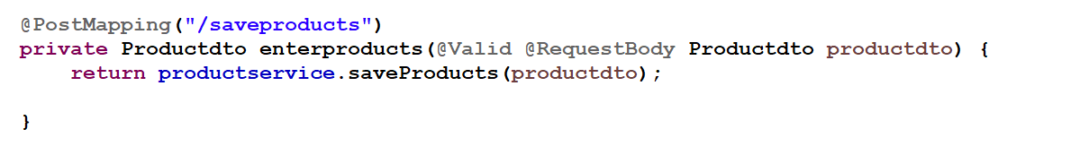

**Input**

<http://localhost:8080/Products/saveproducts>

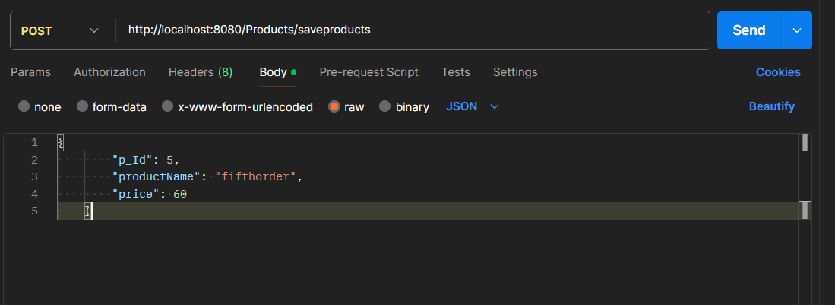

**Output:**

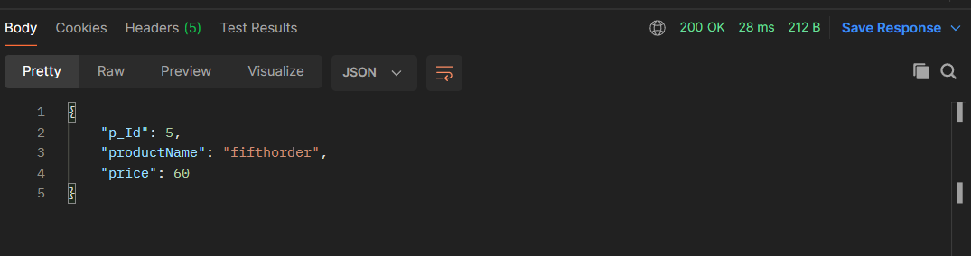

1. **Retrieve Operation**

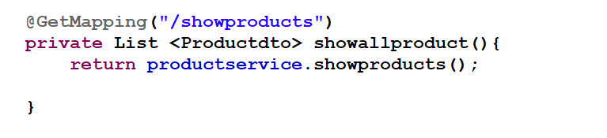

**Input:**

http://localhost:8080/Products/showproducts

**Output:**

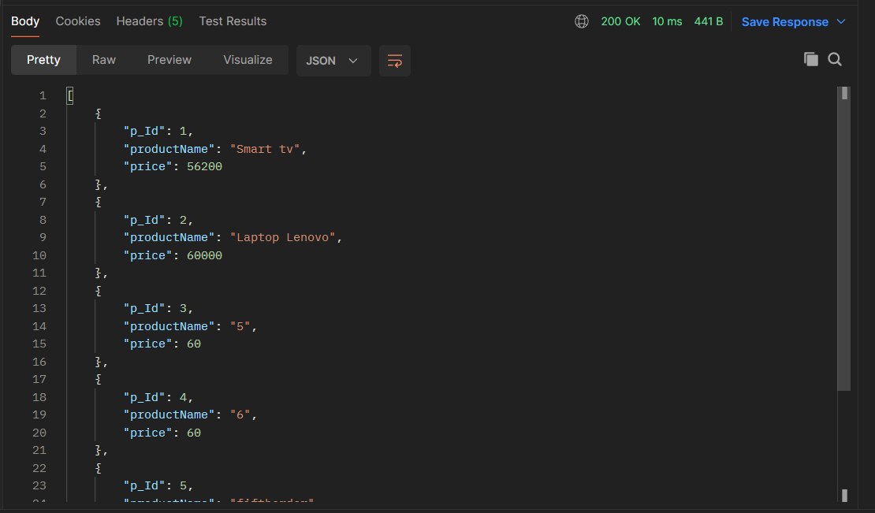

1. **Retrieve Product By Id**

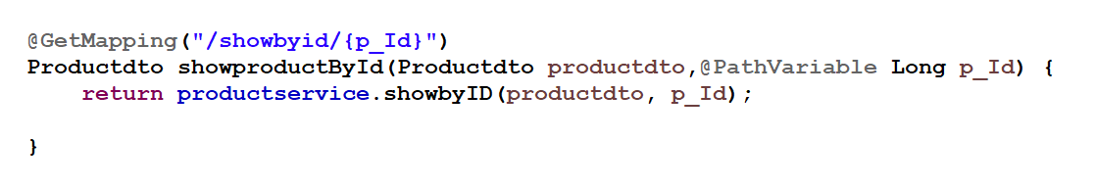

**Input:**

http://localhost:8080/Products/showbyid/{p_Id}

<http://localhost:8080/Products/showbyid/2>

**Output:**

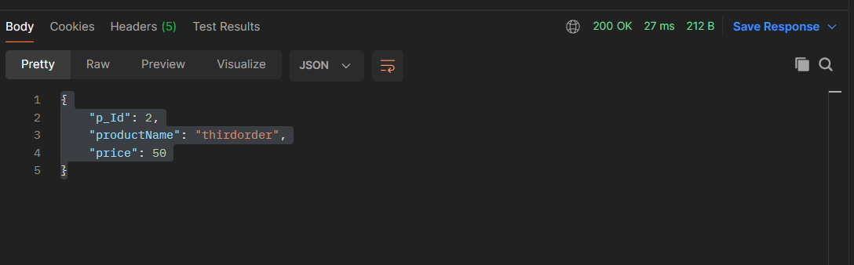

1. **Update Products by id:**



**Input:**

<http://localhost:8080/Products/Updatebyid/2>

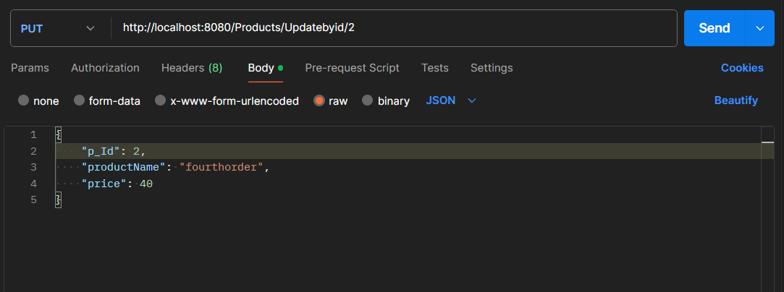

**Output:**

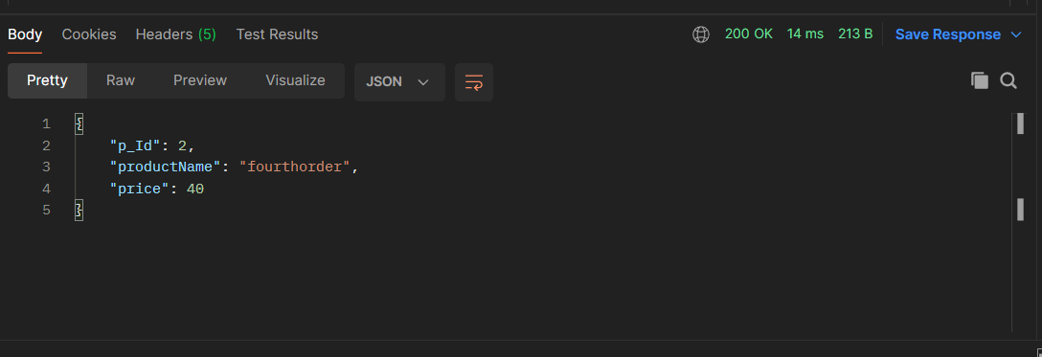

1. **Delete Product by Id:**

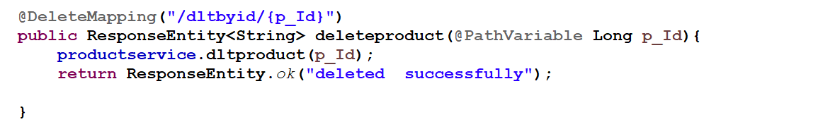

**Input:**

<http://localhost:8080/Products/dltbyid/12>

**Output:**

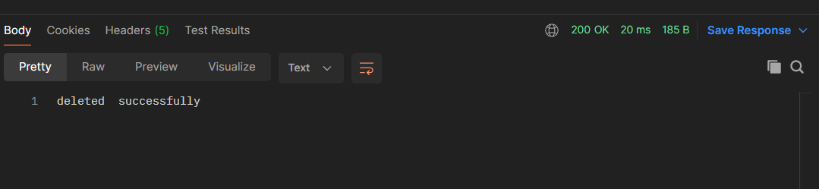

**Order Controller**

1. **Create operations :**

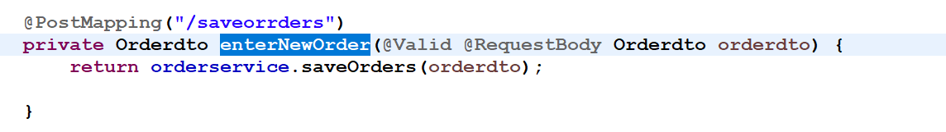

**Input:**

http://localhost:8080/orders/saveorrders

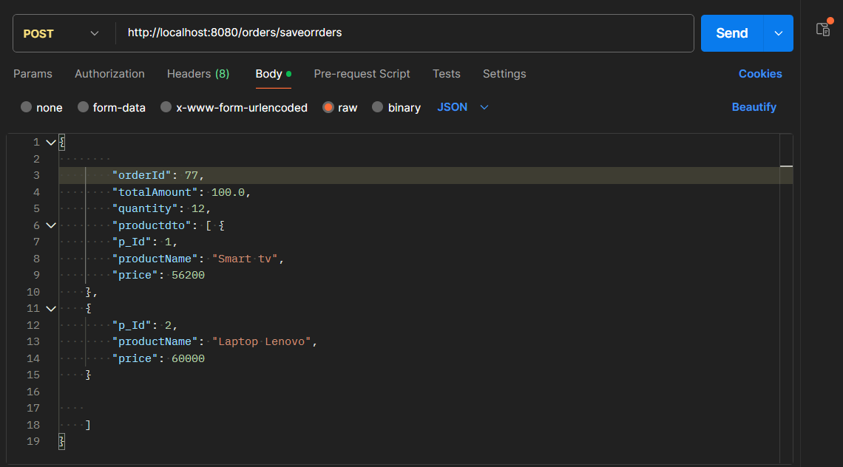

**Output:**

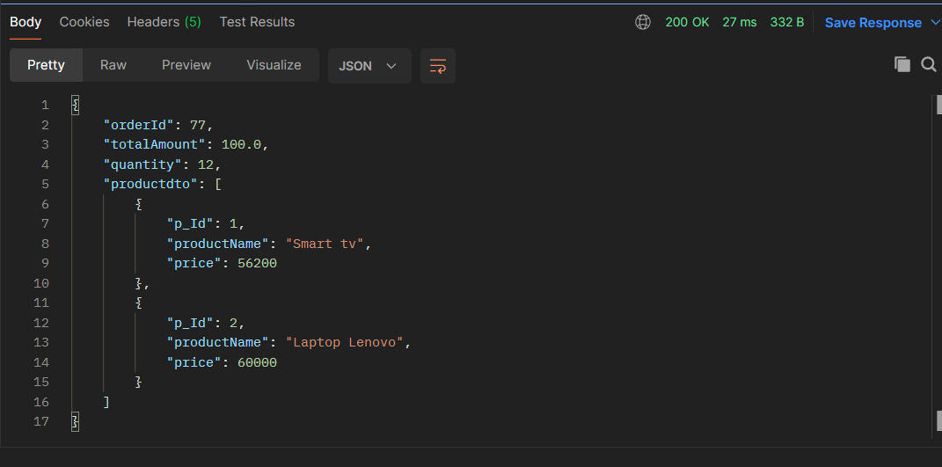

1. **Retrieve Operation:**

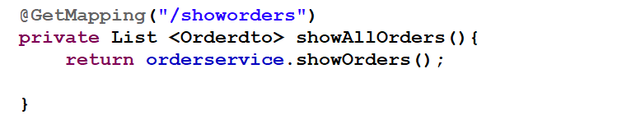

**Input:**

<http://localhost:8080/orders/showorders>

**Output:**

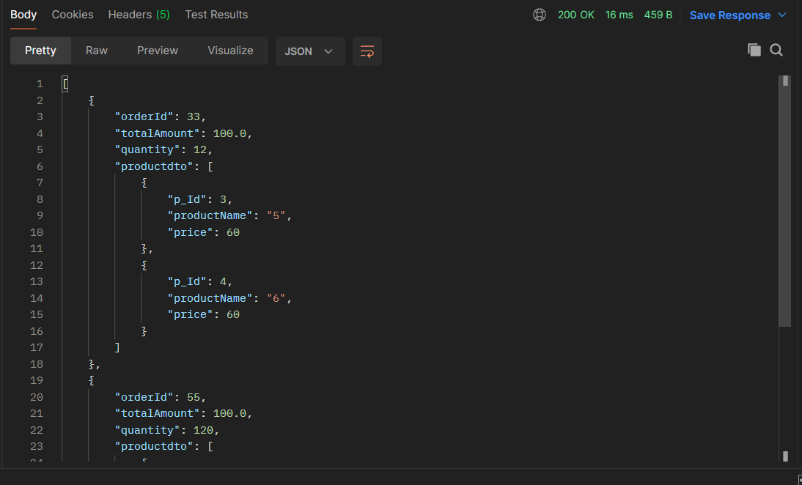

1. **Retrieve by Id:**

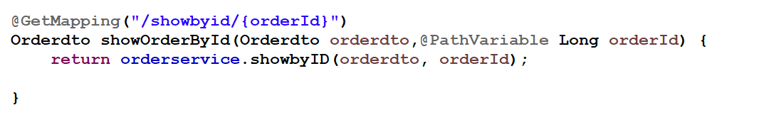

**Input:**

[http://localhost:8080/orders/showbyid/{orderID}](http://localhost:8080/orders/showbyid/%7borderID%7d%203)

<http://localhost:8080/orders/showbyid/33>

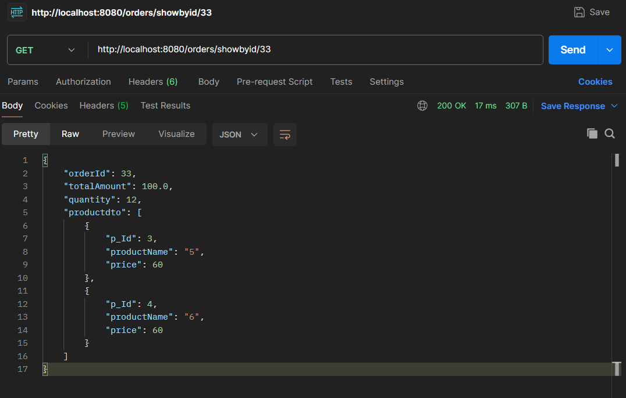

1. **Update by Id:**

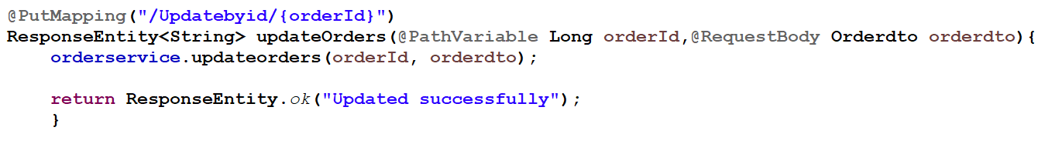

**Input:**

<http://localhost:8080/orders/Updatebyid/55>

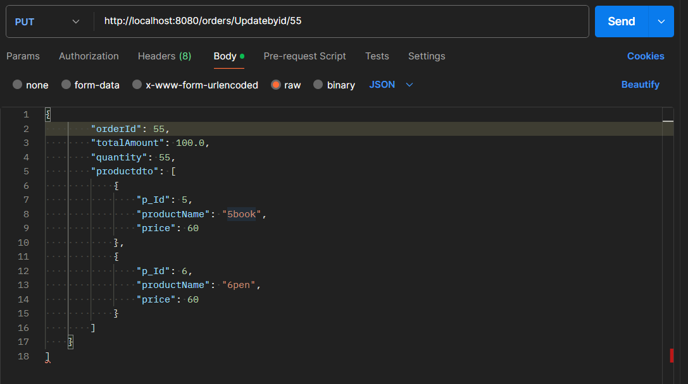

**Output:**

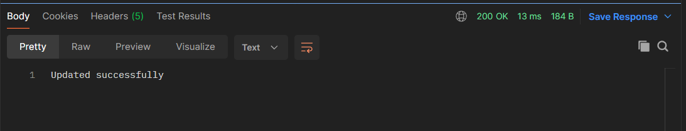

1. **Delete by Id:**

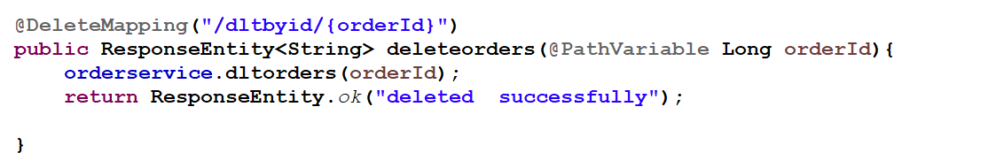

**Input:**

[http://localhost:8080/orders/dltbyid/{orderId}](http://localhost:8080/orders/dltbyid/%7borderId%7d)

<http://localhost:8080/orders/dltbyid/55>

**Output:**

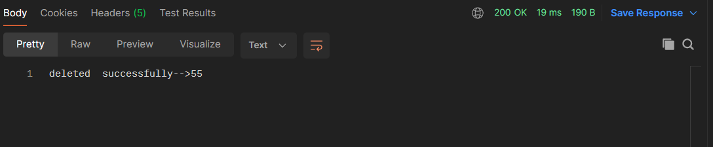

**Batch configuration :**

Product.csv file

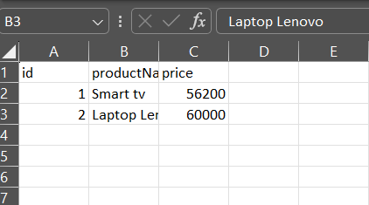

**MySQL Database:**

1. **ProductDto table**

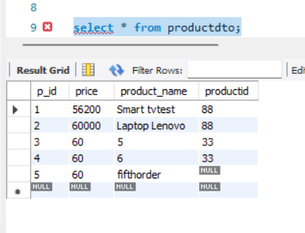

1. **OrderDto Table:**

